My favorite airplane

V-22 Osprey
– A tiltrotor aircraft



AOE4984
Configuration Aerodynamics

Instructor: Dr. Mason

By: Wang Hongwei

V-22 Osprey – A tiltrotor aircraft

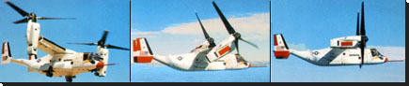
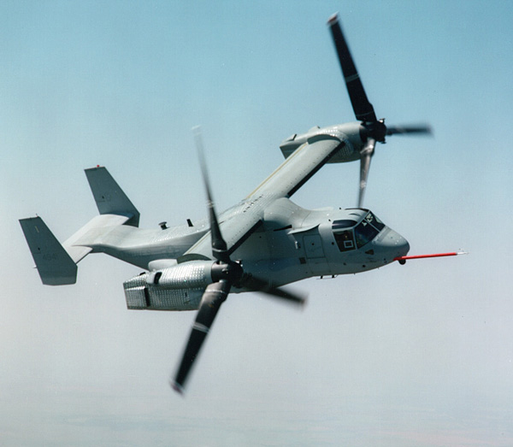

Is it a helicopter or an airplane?
A tiltrotor aircraft.
Helicopter + Airplane = Heliplane.

What it is:
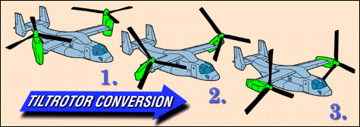
- When the engines are vertical, the tiltrotor aircraft operates like a helicopter. The rotors provide lift and control.
- As the engines are tilted downward, the tiltrotor aircraft accelerates. The wings generate lift as speed increases. Control is achieved via the rotors and conventional aerodynamic surfaces.
- when the engines are horizontal, the tiltrotor operates as a conventional turboprop airplane. Lift is provided by the wings and control is provided by conventional airplane control surfaces.

1. History:

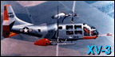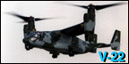

• The Bell XV-3 in the 1950s and 60s demonstrated concept feasibility.
• The Bell XV-15 in the 1970s demonstrated technology maturity.
• In 1982, Bell and Boeing teamed to develop the V-22 Osprey, V-22 first
fly in 1989.
• The Bell-Boeing V-22 in the 1980s and 90s proved tiltrotor capabilities,
mission suitability, producibility and affordability.
• The U.S. Government and Industry have invested 40 years and $5 billion
developing tiltrotor technology.
TILTROTORS - A UNIQUE TECHNOLOGY MADE ONLY IN THE USA.

2. Why tiltrotor?

- Better than a helicopter
• High speed
• High altitude
• More quiet
• Less vibration → Better reliability → Lowering costs.
- Better than an airplane
• Vertical takeoff and landing → More flexible
• Engines at tip → Higher yaw inertial
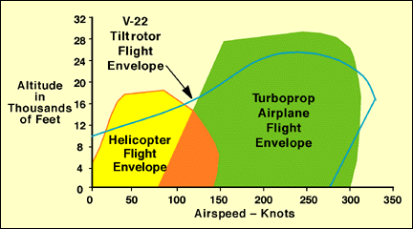
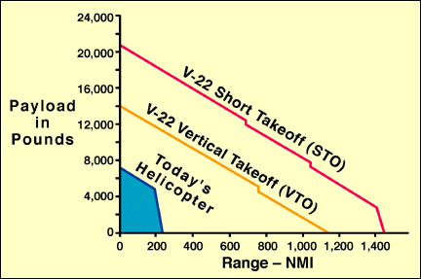

3. Specifications:

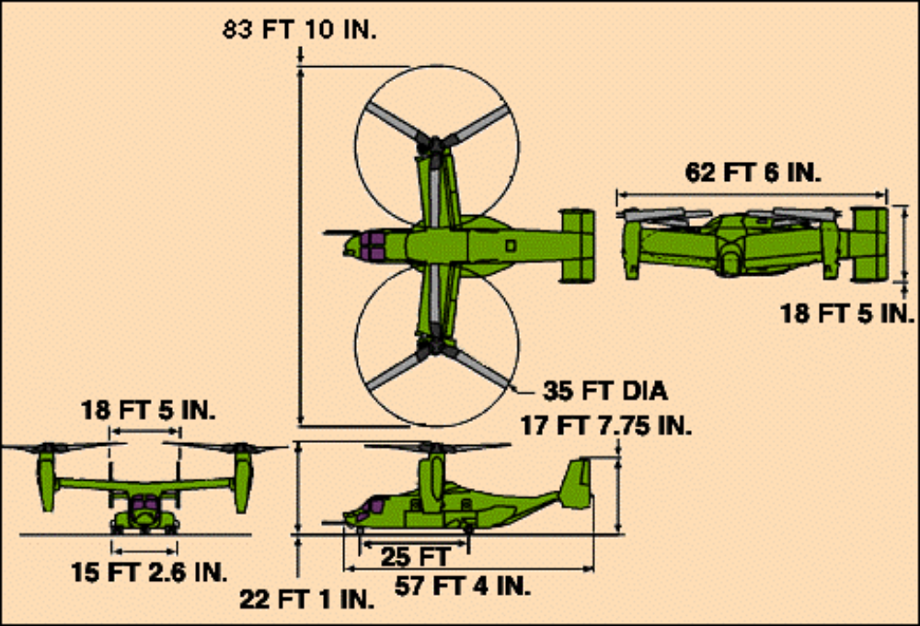

Aerodynamic Characteristics:
- Span: 41ft 1.75in
- Chord: 8ft 0.90in
- Tape Ratio: 1.0
- Sweep angle: -7° (Fore Sweep)
- Aspect Ratio: 5.1
- H Tail

Dimensions
- Length, fuselage - 57.33 ft (17.48 m)
- width, rotors turning - 83.83 ft (25.55 m)
- Height, nacelles fully vertical - 22.08 ft (6.73 m)

Weights
- Empty 33,140 lb (15,032 kg)
- Takeoff, vertical, maximum 47,500 lb (21,546 kg)

Performance
- Maximum speed at sea level - 275 kt (510 km/hr)
- Vertical rate of climb at sea level - 1,090 ft/min (332 m/min )
- Maximum rate of climb at sea level - 2,320 ft/min (707 m/min)
- Service ceiling - 26,000 ft (7,925 m)

Engines
- Manufacturer - Allison Gas Turbine Division
- Model - Two T406-AD-400
- Maximum and Intermediate - 6,150 shp (4,586 kw)

Rotor System
- Blades per hub - three
- Construction - graphite/fiberglass
- Tip speed - 661.9 fps (201.75 mps)
- Diameter - 38 ft (11.58 m)

4. V-22 design

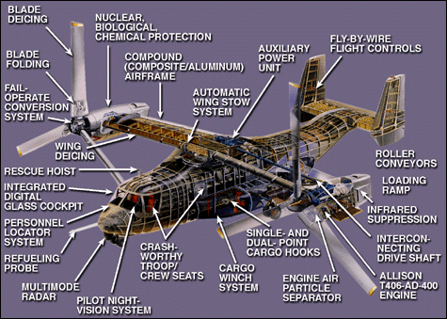
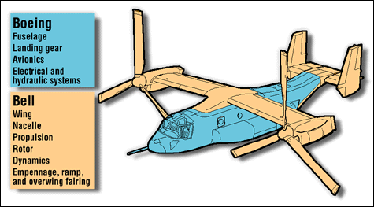
Bell-Boeing Team Work Split
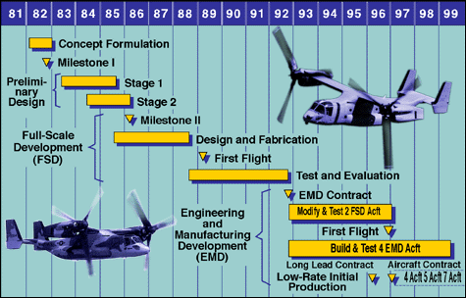
V-22 Program Schedule
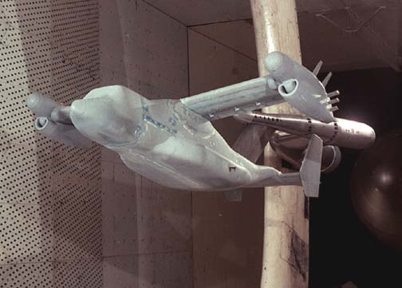
Wind Tunnel Test
Flight Test:
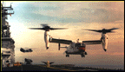  Shipboard Compatibility | 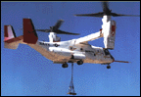  External Loads | 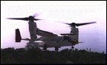  Confined Area Landings

Multimission use by all military services

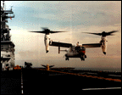 | Combat Assault | 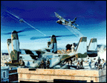 | Long-Range Special Operations
 | Combat Search & Rescue |  | Medical Evacuation
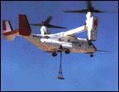 | Assault Support |  | Special warfare
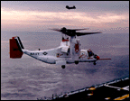 | Fleet Logistics Support

5. Future Tiltrotor Development
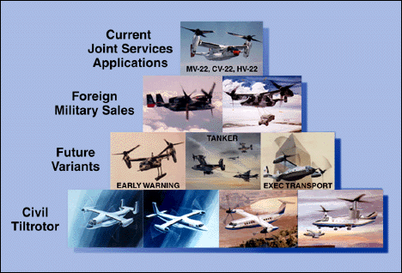

Passenger plane
- An airplane that doesn't require a runway
- Speed, range and altitude of turboprops
- All-weather operations
- Multi-use aircraft

Transportation plane
- Fast, convenient, cost-competitive
- Point-to-point air service
- Increased airport passenger throughput
- Simplified access to congested urban areas
- A new link in intermodal transportation

Reference:
http://www.v-22.com/
http://www.boeing.com/rotorcraft/military/v22/
http://www.navair.navy.mil/v22/index.htm
http://www.theaviationzone.com/facts/v22.htm
http://www.airforce-technology.com/projects/osprey/index.html
http://www.bellhelicopter.textron.com/products/tiltRotor/v22/index.html
http://www.ainonline.com/haiday2_v22.htm
http://www.boeing.com/rotorcraft/military/v22/v22news.htm

